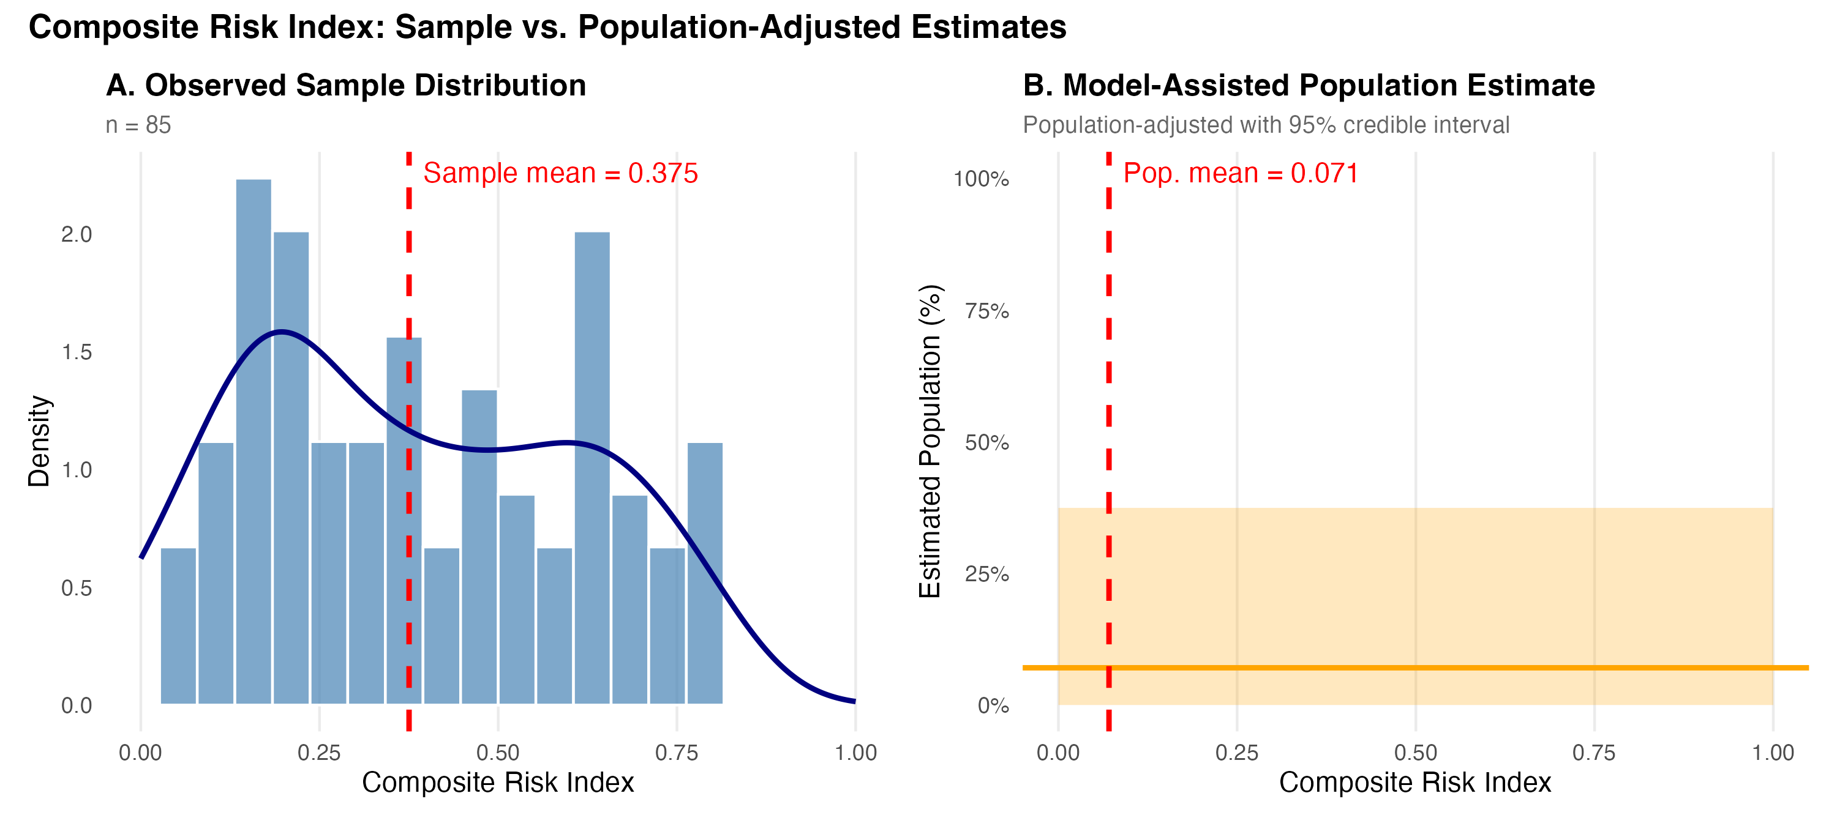
Figure 2. Composite Risk Index: Sample vs. Population-Adjusted Estimates. Panel A shows the empirical distribution of the composite risk index in the observed RDS sample (n=85), with the sample mean marked. Panel B shows the Model-Assisted (MA) population estimate with its 95% credible interval, adjusted for RDS sampling bias. Source: Authors' own work.

